# Assignment 1

## **QUESTION:** What is Cache Memory?

**ANSWER:** Cache Memory is a very high-speed memory. It is used to speed up and synchronize with a high-speed CPU. Cache memory is costlier than main memory or disk memory but economical than CPU registers. Cache memory is an extremely fast memory type that acts as a buffer between RAM and the CPU. It holds frequently requested data and instructions so that they are immediately available to the CPU when needed. Cache memory is used to reduce the average time to access data from the Main memory. The cache is a smaller and faster memory which stores copies of the data from frequently used main memory locations

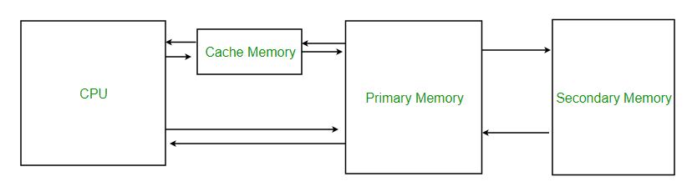

## **QUESTION:** What is Disk Management?

**ANSWER:** It allows users to view and manage the disk drive installed in the computer and also see the partition associated with those drives. You can create a partition in the drives and install different programs (like different OS) in the drives.

## **QUESTION:** Cache vs RAM?

**ANSWER:**

|  |  |
| --- | --- |
| **RAM** | **Cache** |
| Read/ Write Rate is Slower than Cache | Read / Write rate is faster than RAM |
| Ram is used for less frequent data | Cache is used to store more frequent data |
| More capacity to store data in RAM | Less Capacity to store data |
| CPU reads RAM after reading Cache | CPU reads Cache before reading RAM. If information is stored in Cache then there is no requirement to read the RAM memory |

## **QUESTION:** HDD vs SSD?

**ANSWER:**

|  |  |
| --- | --- |
| **HDD** | **SSD** |
| HDD is Mechanical. It has moving parts which are responsible for reading and writing the data. | They store information on Flash memory which consists of individual memory cells storing bits that are instantly accessible |
| HDD requires more power due to moving mechanical parts | SSD requires less power hence it results into more battery life |
| HDD are fragile and can lead to data failure if dropped | SSD are usually safe if the system is dropped by mistake |
| Copying and Moving huge files generally takes 3-150 MB per second in HDD | In SSD, it take generally 500 MB/ Second for a Normal SSD and it can go up to 3500 MB/Second |
| Cheaper compared to SSD | Costlier than HDD |